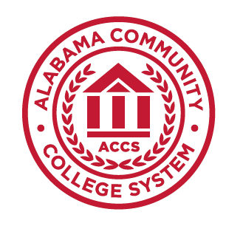
Alabama Community
College System

MTH 232
Math for the Elementary Teacher II

- MTH 232 Math for the Elementary Teacher II– 3 Semester Hours

- Course Description

This course is designed to provide mathematical insights into measurement and geometry for students majoring in elementary education. Topics include geometric shapes (two- and three-dimensional), measurement, congruence and similarity, symmetry, and transformations.

- Prerequisite

Grade of C or higher in MTH 100 or appropriate placement score

- Textbook

Due to the varied selection of quality college-level textbooks, each college will select the textbook needed to meet the requirements of this course.

- Course Learning Outcomes

By the end of the course, students will be able to:
  - apply techniques, tools, and formulas to determine measurements for length, area, and volume;
  - analyze characteristics and properties of two-and three-dimensional geometric shapes and angles; and
  - determine the conditions for congruence and similarity of geometric figures.

- Course Outline of Topics

  - Beginning geometry
  - Polygons and circles
  - Angle measures
  - Three-dimensional geometry
  - Transformations and congruence
  - Similarity
  - Symmetry
  - Systems of measurement
  - Circumference, perimeter, and area
  - Surface area and volume
  - Pythagorean Theorem

- Evaluation and Assessment

Grades will be given based upon A = 90 – 100%, B = 80 – 89%, C = 70 – 79%, D = 60 – 69%, and F = below 60%.

- Attendance

Students are expected to attend all classes for which they are registered. Students who are unable to attend class regularly, regardless of the reason or circumstance, should withdraw from that class before poor attendance interferes with the student’s ability to achieve the objectives required in the course. Withdrawal from class can affect eligibility for federal financial aid.

- Statement on Discrimination/Harassment

It is the official policy of the Alabama Community College System and entities under its control, including all Colleges, that no person shall be discriminated against on the basis of any impermissible criterion or characteristic, including, without limitation, race, color, national origin, religion, marital status, disability, sex, age, or any other protected class as defined by federal and state law. (ACCS Policies 601.02 and 800.00)

- Americans with Disabilities

The Rehabilitation Act of 1973 (Section 504) and the Americans with Disabilities Act of 1990 state that qualified students with disabilities who meet the essential functions and academic requirements are entitled to reasonable accommodations. It is the student’s responsibility to provide appropriate disability documentation to the College.

